4、审核审批列表

## 1、页面查询字段

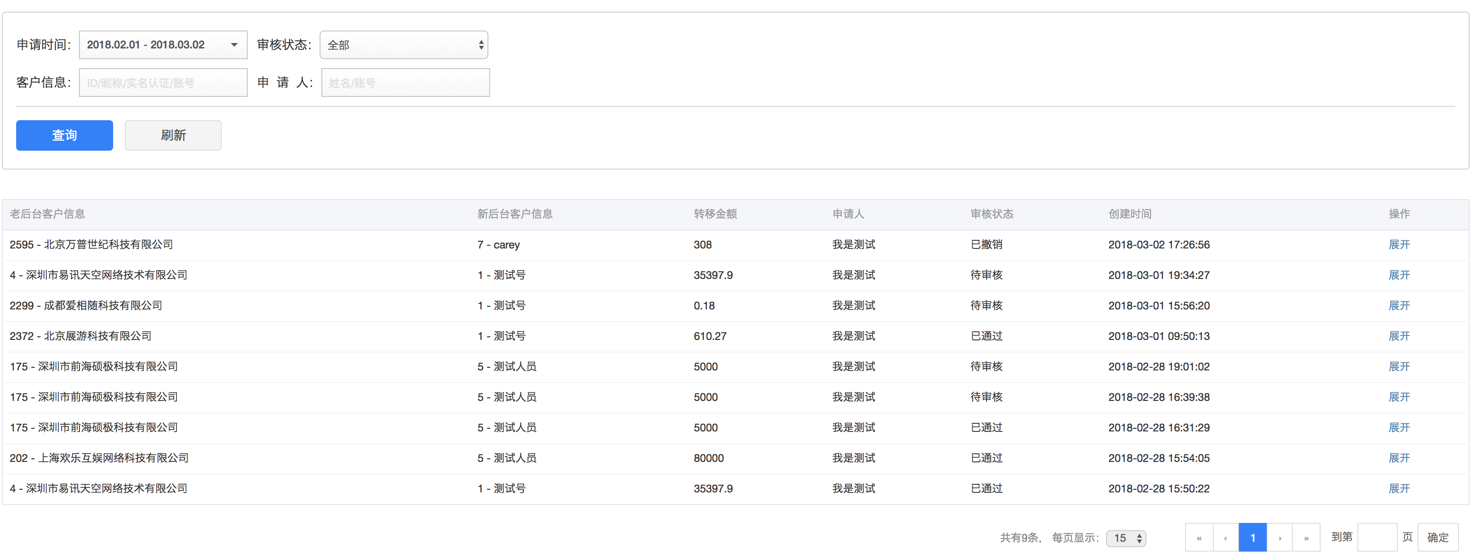

# 2、controller

@RequestMapping("data")  
@ResponseBody  
public Page<OldBackGroundBalanceTransferUser> getOldBackGroundBalanceTransferUserPage(  
 @RequestParam(defaultValue = "0")Integer page,  
 @RequestParam(defaultValue = "15")Integer pageSize,  
 UserQuery query){  
 Pageable pageable = new PageRequest(page, pageSize);  
 SysAdminUser adminUser = AppSessionHelper.getSessionUser();  
  
 return vertifyOldBackGroundBalanceTransferService.getOldBackGroundBalanceTransferUserPage( pageable, query, adminUser.getId());  
}

# 3、查询query实体

public class UserQuery implements Serializable {  
 private static final long ***serialVersionUID*** = 940316731002245128L;  
  
 private Long userId;  
 private String userName;  
 private String nickName;  
 private String authName;  
 private String userParam;  
 private String admParam;  
  
 private Integer userType;  
  
 private Integer status;  
 private Integer authStatus;  
 private Integer waitWhichRoleVerify; //用于审核时判断角色  
 private Integer noSwjlFlag; //无商务经理客户 0-false-有商务经理 1-true-无商务经理  
  
 private Integer offset;  
 private Integer limit;  
 private Date startDate;  
 private Date endDate ;  
  
  
 private String admIds;  
 private String userIds;

# 4、service

@Override  
public Page<OldBackGroundBalanceTransferUser> getOldBackGroundBalanceTransferUserPage(Pageable pageable, UserQuery query, Long admId) {  
  
 //取得日期的最开始时间  
 query.setStartDate(DateHelper.getDateFirstTime(query.getStartDate()));  
 query.setEndDate(DateHelper.getDateLastTime(query.getEndDate()));  
 query.setOffset(pageable.getOffset());  
 query.setLimit(pageable.getPageSize());  
  
  
  
 List<OldBackGroundBalanceTransferUser> list = oldBackGroundBalanceTransferUserMapper.findOldBackGroundBalanceTransferApplyList(query);  
  
 if (CollectionUtils.isNotEmpty(list)){  
 for (OldBackGroundBalanceTransferUser oldBackGroundBalanceTransferUser : list){  
 oldBackGroundBalanceTransferUser.setAttachmentList(oldBackGroundBalanceTransferUserAttachmentDAO.findByEventId(oldBackGroundBalanceTransferUser.getId()));  
 }  
 }  
 Long count = oldBackGroundBalanceTransferUserMapper.countOldBackGroundBalanceTransferApplyList(query);  
  
 return new PageImpl<>(list, pageable, count);  
}

# 5、mapper sql

## 1、了解各自关系 ，首先明确我们要获取的东西，

*<?*xml version="1

.0" encoding="UTF-8"*?>*<!DOCTYPE mapper PUBLIC "-//mybatis.org//DTD Mapper 3.0//EN" "http://mybatis.org/dtd/mybatis-3-mapper.dtd" *>*<mapper namespace="com.duodian.admore.dao.db.user.OldBackGroundBalanceTransferUserMapper">  
  
 <!--统计审批报表中的 审核查询信息中的数据-->  
 <select id="findOldBackGroundBalanceTransferApplyList" resultType="com.duodian.admore.entity.db.user.OldBackGroundBalanceTransferUser">  
 SELECT  
 t.*\**,  
 a.nickName userNickName,  
 ifnull(c.realName,b.realName) userAuthName,  
 h.name cuserName #创建者名字  
 FROM user_old_background_balance_trannsfer t  
 LEFT JOIN user a ON a.id = t.userId  
 LEFT JOIN user_auth_personal b on b.userId = t.userId AND b.status = 1 #先从个人认证中找，找不到的从下面的企业认证中找  
 LEFT JOIN user_auth_enterprise c on c.userId = t.userId AND c.status = 1  
 LEFT JOIN sys_admin_user h ON h.id = t.adminId

#在where中写入条件  
 <where>  
 <include refid="findOldBackGroundBalanceTransferApplyListWhere"></include>  
 </where>  
 order by t.id desc  
 <if test="offset != null and limit != null">  
 limit #{offset}, #{limit}  
 </if>  
 </select>  
  
 <sql id="findOldBackGroundBalanceTransferApplyListWhere">  
 <if test="startDate != null">  
 AND t.cdate &gt;= #{startDate}  
 </if>  
 <if test="endDate != null">  
 AND t.cdate &lt;= #{endDate}  
 </if>  
 <if test="userParam != null and userParam != ''">  
 AND (t.userId = #{userParam}  
 OR a.nickName LIKE CONCAT('%',#{userParam},'%' )  
 OR b.realName LIKE CONCAT('%',#{userParam},'%' )  
 OR c.realName LIKE CONCAT('%',#{userParam},'%' )  
 OR t.customerId LIKE CONCAT('%',#{userParam},'%' )  
 OR t.customerName LIKE CONCAT('%',#{userParam},'%'))  
 </if>  
   
 <if test="admParam != null and admParam != ''">  
 AND (t.adminId = #{admParam}  
 OR h.name LIKE CONCAT('%',#{admParam},'%' )  
 OR h.email LIKE CONCAT('%',#{admParam},'%' ))  
 </if>  
 <if test="status != null">  
 AND t.auditStatus = #{status}  
 </if>  
 </sql>  
  
  
</mapper>

# 6、查找审核人和抄送人，以及状态，点击查看详情（根据work_default id 查找审核人和抄送人）

@RequestMapping("getApprDataList")  
@ResponseBody  
public ResponseBean getApprDataList(Long pid){  
 try {  
 return ResponseBean.buildSuccess(workflowService.getApprDataListByPidAndTaskType(pid, EnumWorkflowTaskType.***老后台余额转移申请***.getType()));  
 } catch (AppException e) {  
 return ResponseBean.buildFailure(e.getMessage());  
 } catch (Exception e) {  
 logger.error(e.getMessage(),e);  
 return ResponseBean.buildFailure(ErrorCodeEnum.***系统错误***);  
 }  
}  
  
@RequestMapping("getCcDataList")  
@ResponseBody  
public ResponseBean getCcDataList(Long pid){  
 try {  
 return ResponseBean.buildSuccess(workflowService.getCcDataListByPidAndTaskType(pid, EnumWorkflowTaskType.***老后台余额转移申请***.getType()));  
 } catch (AppException e) {  
 return ResponseBean.buildFailure(e.getMessage());  
 } catch (Exception e) {  
 logger.error(e.getMessage(),e);  
 return ResponseBean.buildFailure(ErrorCodeEnum.***系统错误***);  
 }  
}

@Override  
public List<WorkflowTaskExamineDetails> getApprDataListByPidAndTaskType(Long pid, Integer taskType) {  
 if (pid == null){  
 throw new AppException("没有获取到pid");  
 }  
 if (taskType == null){  
 throw new AppException("没有获取到taskType");  
 }  
 WorkflowTask task = workflowTaskDAO.findTopByTaskTypeAndPid(taskType, pid);  
 if (task == null){  
 throw new AppException("没有查询到流程记录");  
 }  
 List<Integer> typeList = new ArrayList<>();

typeList.add(EnumWorkflowTaskUserType.***审批人***.type);  
 List<WorkflowTaskExamineDetails> apprDataTempList =

workflowMapper.findWorkflowTaskExamineDetailsByTaskIdAndAdmTypeList(task.getId(), typeList);  
 List<WorkflowTaskExamineDetails> apprDataList = new ArrayList<>();  
  
 WorkflowTaskExamineDetails withdraw = null;  
  
 if (CollectionUtils.isNotEmpty(apprDataTempList)) {  
 for (WorkflowTaskExamineDetails examineDetails : apprDataTempList) {  
  
 if (examineDetails.getExamineStatus().compareTo(EnumWorkflowTaskExamineStatus.***撤回作废***.type) == 0){  
 withdraw = examineDetails;  
 continue;  
 }  
 if (examineDetails.getExamineStatus().compareTo(EnumWorkflowTaskExamineStatus.***等待审批***.type) == 0  
 && task.getStatus().compareTo(EnumWorkflowTaskStatus.***撤回作废***.type) == 0){  
 break;  
 }  
 apprDataList.add(examineDetails);  
  
 if (examineDetails.getExamineStatus().compareTo(EnumWorkflowTaskExamineStatus.***审批拒绝***.type) == 0){  
 //有审批人拒绝了 流程结束 后面的审批人不再显示了  
 break;  
 }  
 }  
 if (task.getStatus().compareTo(EnumWorkflowTaskStatus.***撤回作废***.type) == 0){  
 if (withdraw == null){  
 withdraw =

workflowTaskExamineDetailsDAO.findTopByTaskIdAndAdmTypeAndExamineStatusOrderByExamineOrderAsc(

task.getId(),EnumWorkflowTaskUserType.***申请人***.type,EnumWorkflowTaskExamineStatus.***撤回作废***.type);  
 }  
 if (withdraw != null) {  
 if (StringUtils.isBlank(withdraw.getAdmName())){  
 SysAdminUser adminUser = sysAdminUserDAO.findOne(withdraw.getAdmId());  
 if (adminUser != null){  
 withdraw.setAdmName(adminUser.getName());  
 }  
 }  
 apprDataList.add(withdraw);  
 }  
 }  
 }  
 return apprDataList;  
}  
  
@Override  
public List<WorkflowTaskExamineDetails> getCcDataListByPidAndTaskType(Long pid, Integer taskType) {  
 if (pid == null){  
 throw new AppException("没有获取到pid");  
 }  
 if (taskType == null){  
 throw new AppException("没有获取到taskType");  
 }  
 WorkflowTask task = workflowTaskDAO.findTopByTaskTypeAndPid(taskType, pid);  
 if (task == null){  
 throw new AppException("没有查询到流程记录");  
 }  
 List<Integer> typeList = new ArrayList<>();  
 typeList.add(EnumWorkflowTaskUserType.***抄送人***.type);  
 return workflowMapper.findWorkflowTaskExamineDetailsByTaskIdAndAdmTypeList(task.getId(), typeList);  
}

## 3、获取抄送人mapper

<select id="findWorkflowTaskExamineDetailsByTaskIdAndAdmTypeList" resultType="com.duodian.admore.entity.db.workflow.WorkflowTaskExamineDetails">  
 SELECT t.*\**,a.name admName FROM workflow_task_examine_details t  
 LEFT JOIN sys_admin_user a ON a.id = t.admId  
 <where>  
 <if test="taskId != null">  
 AND t.taskId = #{taskId}  
 </if>  
 <if test="typeList != null and typeList.size() > 0">  
 AND t.admType IN  
 <foreach collection="typeList" index="index" item="at" open="(" separator="," close=")">  
 #{at}  
 </foreach>  
 </if>  
 </where>  
 ORDER BY t.admType ASC ,t.examineOrder ASC ;   
</select>